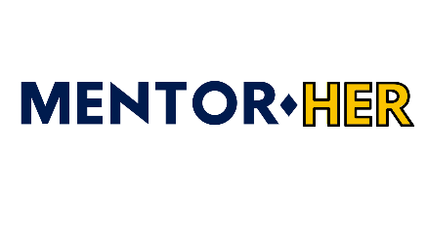
Workshop Form

Thank you for your interest in hosting a workshop, seminar or Q and A with Mentor Her. As part of our program, Mentor Her hosts workshops for our Mentees and Mentors on our six-week program that takes place throughout the year. At the moment, these workshops are hosted on Zoom and last roughly one hour. As part of our program, we want to help women develop their career and business but also their lifestyle, mindset, and outlook as part of our program. We choose our workshop hosts and topics based on the number of women on the program, our budget, current society affairs and other topics that might be relevant at certain times of the year, i.e. seasonal business scaling at Christmas or New Year’s Resolutions around January. In the below form, let us know your name, title and email address alongside your ideas for a workshop and pricing. If you are a past or present Mentor on our program, we will be able to view your biography on our website so please just type “see Mentor biography” in qualifying experience. As we receive a high volume of workshop hosts requests, and book our workshops in advance, we will be back in touch with you in due course about our next program.

Full Name and Title

Email address

Qualifying experience
Suggested workshop ideas for our Mentees and Mentors

Price of one hour workshop

